**Major drone hardware components:**

Here are the major components listed of our project which I have not learned before this course or have implemented these components before:

* DJI 2212 920KV Brushless Motor for Drone
* DJI F450 Frame
* Ardupilot APM 2.8 Flight Control Board Bend Pin with Protective Case
* Robocraze Fly sky CT6B Remote 6 Channel Transmitter and Receiver for Quadcopter RC-A-004
* Lipo Battery 2200mAh / 11.1V
* 6.6 GPS- LM2596 dc-dc buck converter step down module with display board
* PM sensor

Much other different hardware was used in this project but since I was particularly new to this I choose to research and know them properly:

**PM sensor**

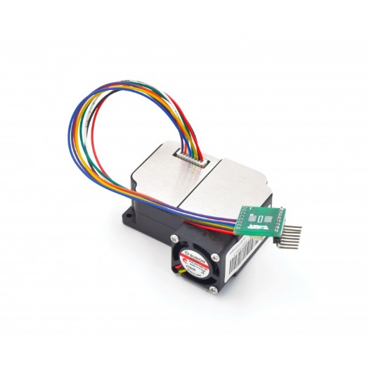

**Figure 8-PM sensor**

Track in real-time PM2.5 dust concentrations. It’s super easy to set up and start using right out of the box with our example Arduino code, along with pre-soldered headers and pre-connected wires. This high precision dust sensor can also be used to measure PM10 in addition to PM1.0. PM1.0 isn’t the concentration standard commonly used by governments or agencies, but it’s just as, if not more important than PM2.5+. We can get a reliable reading of dust concentrations between 0.3 to 10um using a light scattering analysis method. This method determines particle motion and density by measuring fluctuations in the intensity of scattered light. The microprocessor then calculates equivalent particle diameter and the number of particles with different diameter per unit volume. This technique enables users to measure very small particles, particles that fall below even 1.0um in size.

**Features**

• Measure PM1.0 pollutant levels or below, down to 0.3um

• Accurate and stable data output

• Serial output

• Onboard fan

• Can connect it directly to a PC with a USB cable

**Specifications**

• Measurable dust diameter: 0.3-1.0 um, 1.0-2.5um, 2.5-10um

• Data unit: ug/m3

• Resolution: 0.3ug/m3

• Range: 0-999ug/m3

• Response Time: less than 10s

• Operating Voltage and Current: 5V, 200mA,

• Sleep Model Current: 2mA

• Port: 3.3V TTL

• Module Dimension: 50.2x45.0x20.8mm

**Pin Definition**

Pin1 VCC (5.0V)

Pin2 GND

Pin3 SET

Pin4 RXD

Pin5 TXD

Pin6 RESET

Pin7 and Pin8 NC

**DJI 2212 920KV Brushless Motor for Drone**

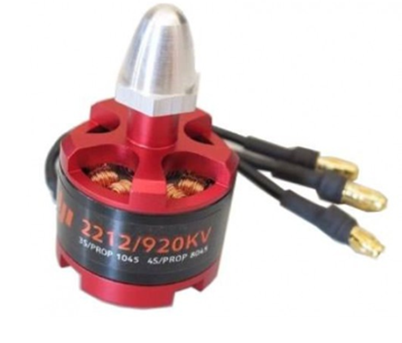

920Kv Brushless DC Motor is a Brushless DC electric motor (BLDC motors, BL motors) also known as electronically commutated motors (ECMs, EC motors) are synchronous motors that are powered by a DC electric source via an integrated inverter switching power supply, which produces an AC electric signal to drive the motor.

**Features of DJI 2212 920KV Brushless Motor:**

• KV(rpm/v): 920.

• Max Power: 370W.

• Max Thrust: 1200 grams.

• Weight: 53 grams.

• Shaft Diameter: 4mm.

• Shaft Length: 49mm Recommended Propeller for battery: 12x4.5 for 2S battery; 10x4.5 for 4S battery.

• Battery: 2S-3S Li-Po.

• ESC (A): FMT 30A (recommended).

**Applications of DJI 2212 920KV Brushless Motor**:

• Used in light weight quadcopters.

**DJI F450 Frame**

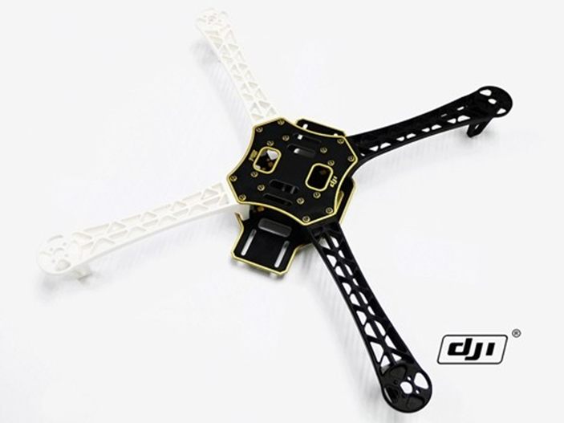

DJI F450 Flame Wheel QuadCopter frame is designed for all pilots for fun or with the use of an autopilot.

The DJI F450 Flame Wheel frames are built from very strong materials, the arms are made from the ultra-strong PA66+30GF material which provides better resistance to damage on hard landings, while the main frame plates use a high strength compound PCB material, which makes wiring of ESCs and battery easy and safe on the lower of the two frame plates which is also the power distribution board. The overall frame design provides enough space when assembled to fit autopilot systems between the top and bottom plates of the Flame Wheel. The arms supplied in the kit are different colours, 2 red and 2 white to allow for improved visual orientation in flight, other coloured arms in black are available.

These frames are very easy to build and are held together by a set of shouldered bolts, the bolts pass through the predrilled holes in the top and bottom frame plates of the F450 Flame Wheel into the top and bottom of the arms, a total of 6 bolts per arm holds the frame plates in place and ensures that the F450 Flame Wheel frame is very solid.

**Applications:**

The Flame Wheel F450 Quad can be used with either the DJI Wookong M Multi Rotor Controller or Naza M V2 autopilot systems to achieve hovering, cruising, even rolling and other flight elements. It can be used for entertainment, aerial photography, FPV and other aero modelling activities

**Frame F450 Flame Wheel specifications:**

Diagonal Wheelbase 450mm

Frame Weight 282g

Takeoff Weight 800g ~1600g

**Ardupilot APM 2.8 Flight Control Board Bend Pin with Protective Case**

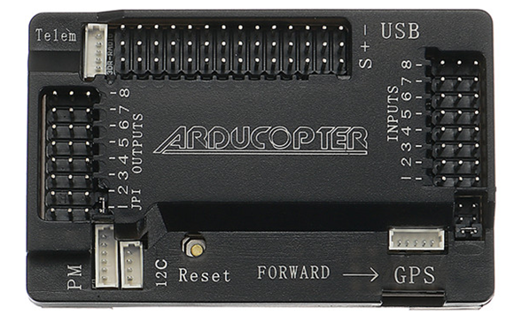

It is a control board that connects in all the rotors and controls the whole of the system. One of the first open source ardupilot systems are Invensense's 6 DoF Accelerometer/Gyro MPU-6000. Barometric pressure sensors are also upgraded to MS5611-01BA03, from Measurement Specialties and Atmel's ATMEGA2560 and ATMEGA32U-2 chips are used for processing and USB functions respectively.

**Features:**

Compatible

Includes 3-axis gyro, accelerometer, along with a high-performance barometer

Onboard 4 MegaByte Dataflash chip for automatic datalogging

Optional off-board GPS, LEA-6H module with Compass

**GPS- Neo-7**

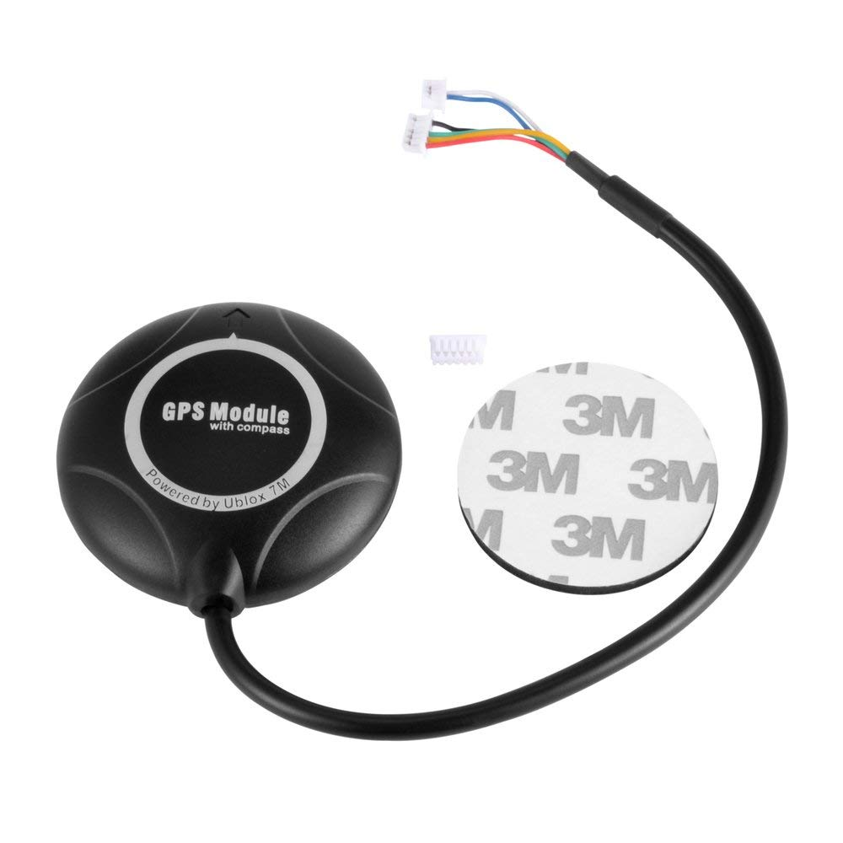

Ublox Neo 7M GPS module includes an HMC5883L digital compass. The new Ublox NEO 7 series is a high sensitivity, low power GPS module that has 56 channels and outputs precise position updates at 10Hz. This GPS module also comes with a molded plastic case which keeps the module protected against the elements making it ideal for use on your aircraft or quadcopter.

This Ublox Neo 7M GPS module uses an active circuitry ceramic patch antenna to provide excellent GPS signal which outperforms the older Ublox Neo 6 series modules. This Ublox Neo 7 module also includes a rechargeable backup battery to allow for HOT starts and also includes an I²C EEPROM to store the configuration settings. Out of the box this GPS module is configured to run at 38400 Baud and is configured to run with APM/Pixhawk systems. This GPS module includes two cables, a 6pin connector for the GPS module and a 4 pin connector for the i2c compass.

**Features:**

1. Locate performance

2. These are Pre-configured, Flashed with the correct settings, and tested to make them play.

3. Super Bright LED

4. Backplane with Standard Mk style mounting holes 45mm X 45mm

5. 38400 bps (Default) Changed to 115200bps!

6. Output GGA, GSA and RMC frames

7. 1Hz (Default) Changed to 5Hz!

8. Permanent Configuration Retention

9. Compass on board

10. 6 pin connector for EZ connect to MEGA BLACK

11. 4 pin connector for only GPS use

12. 4 pin connector for compass only use

13. Can use both 4 pin at once.

**Lipo Battery 2200mAh / 11.1V**

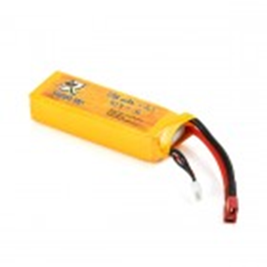

Lipo Battery 2200mAh / 11.1V has three cells and outputs 11.1V storing 2200mAh of charge. This is a good Lipo battery for projects like small robotics and radio-controlled projects. It has high discharge rates and big capacity and can be used in RC airplane, RC helicopter, RC car, RC truck, RC boat, drone applications. This high power output battery has very special internal structure, which requires dedicated balance charger to charge. Li-Poly Battery Charger is a suitable mate. IMAX-B6AC Battery Charger can be used to recharge this module.

**Specifications of Lipo Battery 2200mAh / 11.1V**

• Material: Li-polymer

• Battery voltage: 11.1 V

• Nominal capacity: 2200mAh

• Max. Charge current: 2.2A

• Discharge: 25C

• Wire length: 50 ± 5mm

**Robocraze Flysky CT6B Remote 6 Channel Transmitter and Receiver for Quadcoopter RC-A-004**

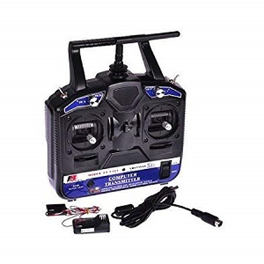

This transmitter requires a PC to modify any of the channel variables, including mixing and servo reversing. This has FS-CT6B 6ch 2.4GHz transmitter & receiver which can transmit 0.8W within a range up to 1km line of sight.

**Specifications:** Channels: 6.

**Frequency:** 2.4GHz.

**Features:**

• Channels: 6 Channels

• Model Type: Heli, Airplane, Glid

• RF Power: Less than 20db

• Modulation: GFSK

• Code Type: 2.4 GHz No Interference